
Submission date: 23 September 2026
Course name: CSC 200/300
Group 15

Table of Contents
1 INTRODUCTION 1-3
2 System Overview 2-3
3 Problem Statement 3-4
4 Solution & Specifications 4-4
5 Requirements 5-5
6 Security 6-7
7 Methodology 7-8
8 Conclusion 8-8
9 Definitions and Acronyms 9-9

INTRODUCTION
This document presents the software requirements and project plan for the UFH Residence Maintenance Portal, a web-based system designed to digitize the reporting and tracking of maintenance faults within University of Fort Hare student residences.
Key Concepts:
- Fault: A reported maintenance issue (e.g., broken light, leaking tap).
- Tradesperson: University maintenance staff assigned to resolve faults.
- Ticket: A digital record of a fault, containing its status, urgency, and history.
Context:
Currently, residence maintenance relies on manual reporting methods, which leads to lost requests, delayed response times, and a lack of transparency for students regarding the status of their repairs. There is a critical need for a centralized digital system to streamline the logging, assignment, and tracking of maintenance faults.
Structure:
This document is organized as follows: Section 2 provides a system overview. Section 3 defines the problem statement. Section 4 presents the proposed solution and specifications. Section 5 outlines the functional and non-functional requirements. Section 6 details the system design, including architecture, data model, and security. Section 7 describes the necessary diagrams. Section 8 details the methodology, testing, and improvements. Section 9 provides the conclusion.

System Overview
Supabase (Backend as a Service)
- Authentication & Roles
- Row-Level Security (RLS)
- Business Logic & Validation
- Edge Functions (Email Alerts)

React (Web Application)
Bullet Points:
User Interface
Maintenance Requests
View Reports

Manage Profile

Supabase Database
- Users (Profiles)
- Maintenance Tickets
- Ticket Updates
- Residence Data

Browser (Client)

Front Front-End
- Auth API
- (University Emails)

- Email API
- (Notifications)

- Storage API
- (Photo Uploads)

Figure 1: System Architecture of the UFH Residence Maintenance Portal
Figure 1 illustrates the architecture of the UFH Residence Maintenance System. The React front-end (right) is the interface students and staff use in their browser, communicating with the Supabase back-end (center) via secure HTTPS requests. The back-end handles authentication, business logic, and data processing. It connects to the Supabase Database (left), which stores user profiles, maintenance tickets, and residence data. It also integrates with three external services: the Email API for notifications, the Storage API for fault photos, and the Auth API for university email verification. This architecture ensures a scalable, efficient, and secure system for managing residence maintenance requests.

Problem Statement
Residence maintenance at the University of Fort Hare currently relies on manual reporting methods. This leads to lost requests, delayed response times, and a lack of transparency for students regarding the status of their repairs. There is a critical need for a centralized digital system to streamline the logging, assignment, and tracking of maintenance faults.

Solution & Specifications
Proposed Solution:
A web-based portal that allows students to log faults directly from their rooms. The system automatically routes the job to available tradespersons and provides the student with real-time updates from report to completion.
Operation Mode (User Mode):
The system operates in a three-stage user workflow:
- Log: Student submits a fault report via the portal.
- Assign: A tradesperson is assigned to the job.
- Track: The student follows the progress until the job is marked complete.
Language & Tools Used:
- Frontend: HTML, CSS, JavaScript (React/Next.js framework).
- Backend: Secure authentication via university email credentials (Supa base).
- Deployment: Vercel.

Requirements
Functional Requirements
- FR-01: Students can register with a UFH email, name, residence, room, and password.
- FR-02: Users choose their role (Student/Tradesperson) when signing in; email format is checked.
- FR-03: Users can reset a forgotten password via an emailed link.
- FR-04: Students can log a fault with category, residence, room, urgency, and description.
- FR-05: Students can attach an optional photo, automatically resized before upload.
- FR-06: Students see only their own requests, with filters.
- FR-07: All users can see the full, time-stamped history of a request.
- FR-08: Students can comment on their own open requests.
- FR-09: Students have a dashboard showing request counts and latest updates.
- FR-10: Tradespeople see a work queue ordered by urgency, then waiting time.
- FR-11: Tradespeople can accept an unassigned job and message the student.
- FR-12: Tradespeople can update a job to "In Progress" and then "Completed".
- FR-13: Tradespeople can add progress notes visible to the student.
- FR-14: Tradespeople have a "My Jobs" list.
- FR-15: Users can update their profile.
- FR-16: Visitors can read the Contact, Terms, and Privacy pages without signing in.
- FR-17: The system emails students when a request is created or updated.

Non-Functional Requirements
- NFR-01 (Security): Passwords are hashed, HTTPS is used, and row-level security controls data access.
- NFR-02 (Privacy): POPIA compliant; students see only their own requests.
- NFR-03 (Usability): Plain-language labels, consistent UFH design, clear error messages.
- NFR-04 (Accessibility): Keyboard navigation, good contrast, and reduced motion support.
- NFR-05 (Responsiveness): Layouts adapt from 360px phones to large monitors.
- NFR-06 (Performance): Photos are shrunk before upload for quick mobile use.
- NFR-07 (Availability): Hosted on managed services (Vercel and Supabase).
- NFR-08 (Maintainability): Shared rules live in one place; code is documented.
- NFR-09 (Portability): Runs in any modern browser with no installation.
- NFR-10 (Reliability): Failed saves show an error; database refusals are reported.
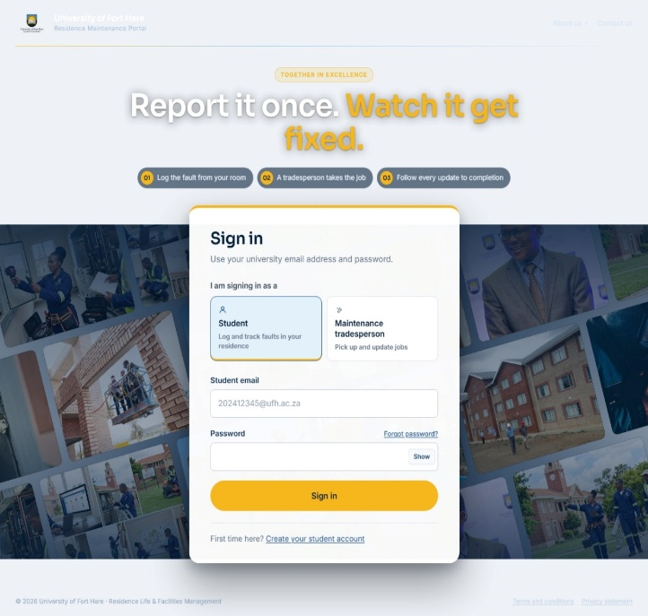

Figure :2 shows the user interface
Figure 3 :shows the page for users to create the account
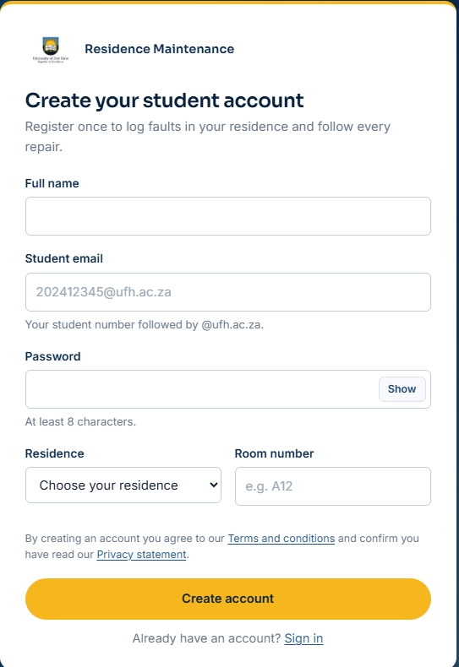

Security
Security is enforced at multiple levels to protect student data and ensure system integrity:
- Authentication: Passwords are securely hashed by Supa base Auth and never stored in plain text. All traffic uses HTTPS.
- Role-Based Access: The system verifies that the email format matches the chosen role (Student vs. Tradesperson) and refuses sign-in if the account belongs to the other role.
- Row-Level Security (RLS): Database policies ensure that students can only read and edit their own requests. They cannot view the requests of other students.
- Storage Security: Photo uploads are restricted to the user's own folder, preventing unauthorised access to other students' images.
- Privacy: Personal information is handled according to the Protection of Personal Information Act (POPIA), explained in the Privacy statement.

Methodology
The project followed an Agile Methodology, focusing on iterative development and user feedback.
- Demo and Testing: The system underwent User Acceptance Testing (UAT). Group members used the system as both students and tradespeople.
- Improvement Cycle: Feedback gathered during testing was used to implement improvements. For example:
- Feedback: "I can't tell the portal whether I am a student or a tradesperson."
- Improvement: Added a role choice on the sign-in page.
- Feedback: "The history only shows names and dates, not what the tradesperson wrote."
- Improvement: Fixed the history to show every note, message, and status change.
- This iterative approach ensured the final product effectively met the needs of the residence maintenance team and students.

Conclusion
This document presented the problem, solution, and design of the UFH Residence Maintenance Portal. It identified that the current manual reporting process causes lost requests, delayed responses, and a lack of transparency for students. To address this, the proposed system provides a centralized web application where students log faults and tradespeople manage and resolve them through a transparent, real-time workflow. The document then outlined the system's functional and non-functional requirements, detailing how authentication, fault logging, job assignment, and status tracking will operate.
The system design was also described, including the React front-end, the Supabase back-end, the PostgreSQL database, and the security measures such as row-level security and POPIA compliance that protect student data. The proposed architecture ensures the system is scalable, secure, and easy to use on both phones and computers. By replacing paper forms and word-of-mouth with a single digital platform, the Residence Maintenance Portal will ensure faults are resolved faster, students are kept informed, and maintenance staff can priorities their work effectively, ultimately improving the overall quality of residence life at the University of Fort Hare.

Definitions and Acronyms
Term / Acronym | Definition
API | Application Programming Interface – a set of rules allowing different software to communicate.
ERD | Entity Relationship Diagram – a visual representation of database tables and their relationships.
Fault | A reported maintenance issue (e.g., broken light, leaking tap).
HTTPS | Hypertext Transfer Protocol Secure – encrypted communication over the internet.
JWT | JSON Web Token – a secure way of transmitting information between parties.
POPIA | Protection of Personal Information Act – South African law governing data privacy.
RLS | Row-Level Security – database rules that restrict which rows a user can access.
Supabase | An open-source backend service providing authentication, database, and storage.
Ticket | A digital record of a fault, containing its status, urgency, and history.
Tradesperson | University maintenance staff assigned to resolve faults.
UAT | User Acceptance Testing – testing performed by end-users to validate the system.
UFH | University of Fort Hare.
Vercel | A cloud platform for hosting and deploying web applications.

